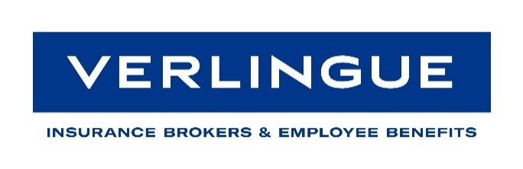
Return to work after COVID19-
Common Questions

COVID 19 has disrupted pretty much every business across the board and it has been a difficult time for all concerned.
However, signs are that businesses and employees want to return to work but are having to do so with a very different set of rules, the overruling one being that of safety and protection from infection.
Every business is different, so it is not possible to include all variables in this short guidance. However, it should give businesses the tools to approach the issue correctly with a view to protecting the workforce and the business.
There is wide speculation that future infections may instigate a spike of claims relating to coronavirus infections in the workplace and attempting to hold the employer responsible for not imposing the correct safety procedures.
A brief tour of Google will reveal a whole host of return to work advice, some of it good, some of it industry specific, some of it has been written by insurers for the types of business they choose to insure and some of it is just wrong. This shot in the dark approach may well leave holes in your systems that could expose you and your business to further infection and employers and public liability claims as a result.
As with any other potential harm in the workplace, the key to managing it successfully is to assess the risk, who it will affect, decide upon your controls, implement them, make sure they are communicated effectively to the workforce and of course, critically, ensure that a full audit trail is in place.
These measures will not only help protect you and your workforce, they will also help to reinforce the new behaviours necessary in the workplace and give employees and contractors/suppliers a greater perception that you are taking their welfare seriously.
The main tool that we would recommend in formulating your return to work process is the government guidance, freely available on the HSE website www.hse.gov.uk It is well written, succinct, pragmatic and deliverable. From a business point of view, it is also likely to be the benchmark that enforcement agencies such as the HSE, environmental health officers and insurers use to both take enforcement action against a business and defend civil claims from employees and members of the public.
Some of the more common issues
In no particular order, some of the following generic issues have arisen in business, but this is not exhaustive. You will need to specifically look at your own business to manage it properly.
- Risk assessments
- Working from home including it becoming a permanent or semi-permanent feature
- Transport arrangements
- In house people movement maintaining 2 metre clearance
- Fire wardens and first aid measures
- Vulnerable persons such as clinical risk and BAME and people with childcare issues
- Getting machinery back online including inspections and maintenance
- Third party site visits
- Managing an outbreak and tracing contact points
Some of the slightly unusual solutions that have arisen to management of the issues
- “Propping” internal doors open to remove touchpoints. Sometimes these are fire doors. Which takes priority, COVID19 or fire? Fire is the general feeling, which leaves some uncomfortable. After all, it is not a daily occurrence. Installing mag release locks on your internal doors can address this. For those who don’t know, these will automatically release and self close on activation of the fire alarm.
- One way systems are being much touted using tape and markers. This is not always possible, but you may be able to make it work.
- Bringing your own food and refreshments in to avoid the lunchtime supermarket/sandwich van exposure.
- Close liaison with joint occupancy businesses. Maybe share fire wardens or first aiders (for emergency use only).
- Regular staff bulletins giving updates. It is important that employees recognise that you are looking after them.
Some of the problems
- Guidance seems to be changing almost daily. It is important to keep your risk assessments updated to reflect this and to ensure readily available communication to staff. The in-house intranet is often a good solution.
- Supply issues. Cleaning products, notably hand sanitiser and certain types of PPE are notoriously difficult and expensive to get at the present time. This may take longer to arrive than usual, so order well in advance.
- IT bandwidth for online business meetings such as Zoom, conference calls, webinars etc may need to be upgraded, as will your in-house security to protect confidentiality. Consideration may also need to be given to upgrading your hardware to allow more working from home via company laptops.
- Some additional furnishings may be necessary, such as screening/partitioning and perhaps extra office space.
- Visitor policies will need to be reviewed to include contractors, engineers and visitors and the like and possibly client meetings if they cannot be done online.

